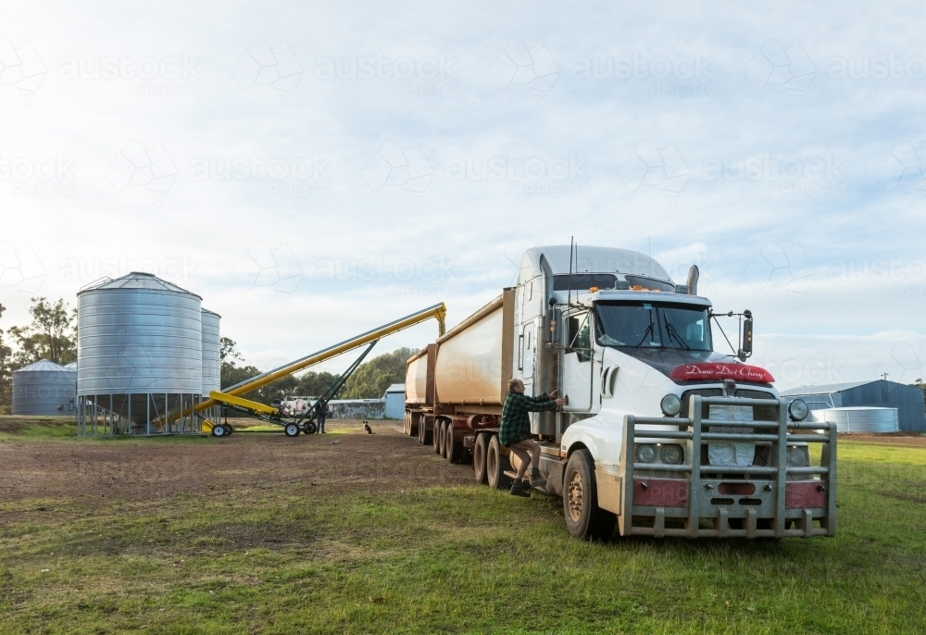

Overview

Grain holding company gets orders to either take in or output grain to trucks. Each order has different types of grain and different amounts, which influence the revenue received for that order. The company has a limited number of silos with limited space and limited time in the day to process all the orders. The company needs to select and schedule orders to maximise profit.

**Algorithm**

Knapsack problem.

<https://www.geeksforgeeks.org/0-1-knapsack-problem-dp-10/>

Each load of grain has a time value (space) and a revenue value. The knapsack algorithm fits the grain loads into the daily schedule as objects in the knapsack

**Program Structure**

Order requests are files read by the program on starting.

Program outputs to console using letters for animation

User can select random assignment, to show algorithm is more efficient

User can also create their own schedule and get program to run it. To show how difficult it is to do by human and just how more efficient algorithm is.

**Main class**

Main function

-create array of all files in folder

-iterate over files in array to create order instances

-put orders through knapsack algorithm

-print output

Knapsac algorithm function

-takes a array of orders

-returns optimum selection of orders for the day

Get files in folder function

-given a folder address

-gets address for all txt files in folder

-returns array of address for txt files

Read file and create order function

-takes string address of txt file

-reads the data in the file

-creates an instance of order class

-returns the instance of the order class

Randomise Algorithm

-takes a array of orders

-returns random selection of orders for the day

**Order Class**

Variables:

Grain type

Size

Load type: either unloading or outloading

Functions:

Get grain type

Get size

Get load type

**Silo Class**

Variables:

Grain type

Grain limit

Current grain level

Functions

Get grain type

Get size

Update grain level

Update grain type

Overflow function

Underflow function

**Business class**

Represents the data and logic of the business

variables:

Day schedule: array represents hours in the day

Revenue: int for money. Can be positive or negative

Silos: array of instances of silos

**functions**

Update schedule

Get schedule

Update revenue

Get revenue

Get silos

**Display Class**

Used to print display and animations

**Road Map**

Iteration one.

Program can read all order txt files from a folder and turn them into instances of order class

Program has business class

Iteration two.

Implement basic knapsac algorithm

inloading only

Program goes on time and $ value of order

No issue with silos overfilling

Iteration three

Knapsac problem can now include outloading as well

Iteration four

Knapsac problem now takes into account grain overflow or underflow